Visualizing Sustainability: A Cognos-based Analysis of Global Trends (2000-2023)

SINDHU L

Assistant Professor,

Department of Information Technology,

Sona College of Technology, Salem, Tamil Nadu, India.

# Introduction:

## Overview

"Visualizing Sustainability: A Cognos-based Analysis of Global Trends (2000-2023)" is a comprehensive project that focuses on analyzing and visualizing global trends related to sustainability over a specific time period. By using advanced data visualization techniques, the project aims to present the complex data in a visually appealing and easily understandable manner. This allows stakeholders, decision-makers, researchers, and policymakers to gain valuable insights into the current state of global sustainability and make informed decisions for the future. By analyzing and visualizing trends, patterns, and correlations in the data, the project aims to highlight the progress made in sustainability efforts, identify areas that require attention and improvement, and project future scenarios based on the available data.

This information can be instrumental in shaping policies, strategies, and initiatives to promote sustainable development and address global challenges.

The project aims to provide a holistic overview of various aspects of sustainability, including environmental, social, and economic factors, and how they have evolved and impacted the world from 2000 to 2023 and facilitating a better understanding of the current state and future trajectory of sustainability efforts worldwide.

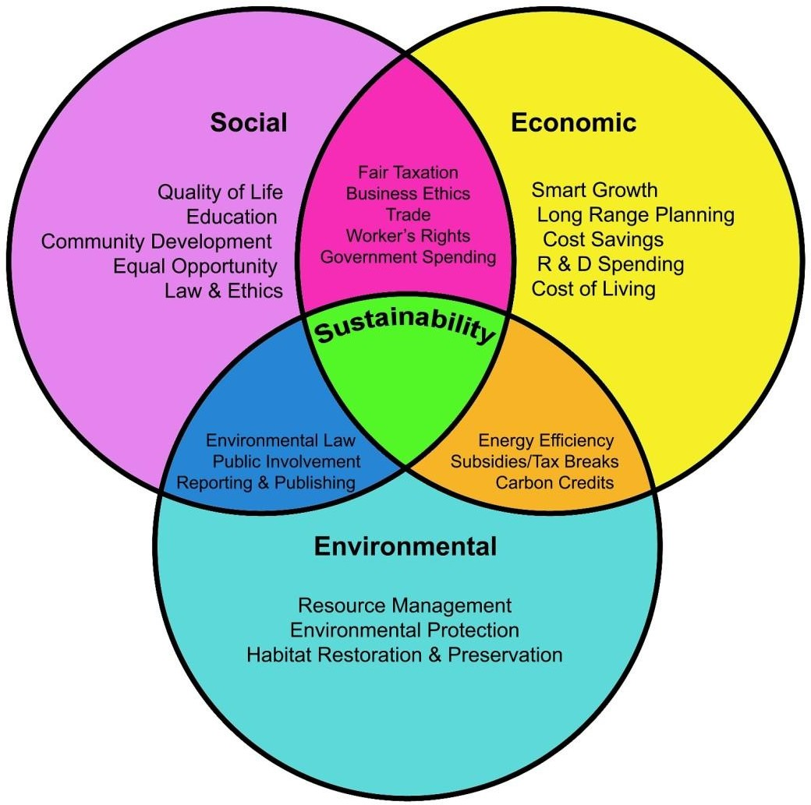

**Fig. 1**

## Purpose

The purpose of the project is to provide a comprehensive understanding of the trends and patterns related to sustainability on a global scale over a specific time period. The project aims to highlight the progress, challenges, and potential future trajectories of sustainability in various domains such as environment, society, and economy. The project's purpose is to facilitate informed decision-making, policy development, and awareness about sustainability issues. It aims to empower stakeholders, including policymakers, researchers, and organizations, with valuable insights to address sustainability challenges effectively and work towards a more sustainable future.

Develop a user-friendly dashboard that leverages the Sustainable Development Report 2023 dataset to provide a comprehensive and insightful analysis of countries' progress towards achieving Sustainable Development Goals (SDGs). Display a ranking of countries based on their overall sustainability scores. Allow users to filter the rankings by region, income group, or specific SDGs. Provide detailed profiles for each country, including its sustainability score, regional classification, and performance on individual SDGs. Users should be able to access historical data to track a country's progress over time. Enable users to compare the sustainability scores and SDG achievements of countries within a specific region. This feature should allow for visual comparisons and trend analysis. Offer

in-depth analysis for each SDG, showing how countries are performing in areas such as poverty reduction, healthcare access, gender equality, climate action, etc.

### Literature Survey

* 1. Existing Problem

In the domain of global sustainability assessment, the primary challenge lies in the lack of comprehensive and accessible tools for analyzing and understanding trends over time. The intricate nature of sustainability, covering environmental, social, and economic dimensions, poses difficulties in distilling meaningful insights from extensive datasets. Existing approaches often struggle to provide a unified view, hindering stakeholders from making well-informed decisions. Example overview of the Social and Environmental challenges faced by the small coffee growers.

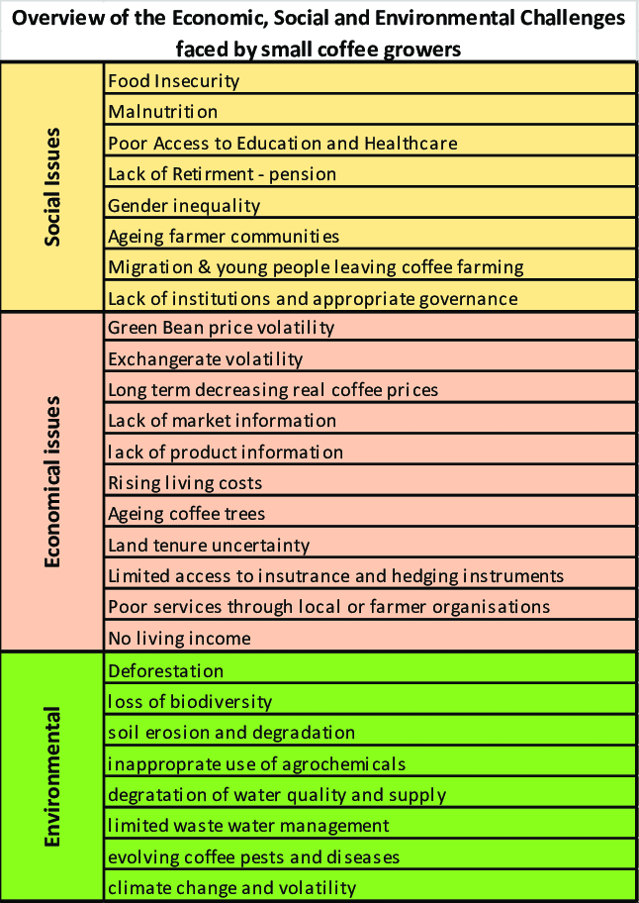

##### Fig. 2

Various approaches have been employed to address these challenges. Traditional reporting systems, for instance, tend to present data in lengthy, text-heavy reports, making it challenging for stakeholders to grasp key insights. Some tools focus on a single dimension of sustainability, such as environmental impact, without offering a holistic view. This narrow perspective overlooks the interconnectedness of environmental, social, and economic factors. Another limitation lies in the lack of tools that can effectively track historical data over an extended period, restricting the understanding of long-term trends. Additionally, existing methods may present data in a complex or non-intuitive manner, making it difficult for non-experts to interpret. The simplification of complex data through intuitive visualization is often overlooked, limiting the accessibility of sustainability insights.

Furthermore, many tools lack interactivity, preventing users from exploring data dynamically and gaining deeper insights. The current landscape falls short in engaging users through interactive features, restricting their ability to customize analyses based on specific criteria. The literature survey underscores a gap in existing approaches, highlighting the need for a user friendly, visually appealing, and comprehensive tool to address the complexities of global sustainability analysis.

The proposed project aims to fill this gap by leveraging advanced data visualization techniques within the IBM Cognos framework. The goal is to provide a solution that empowers stakeholders with actionable insights, facilitating informed decision-making for sustainable development.

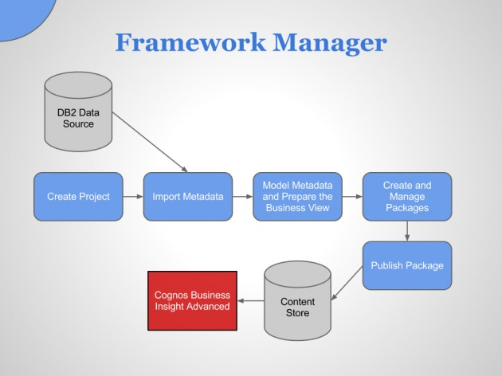

**Fig. 3**

### Proposed solution

Addressing the limitations observed in existing approaches, the proposed solution centers on leveraging advanced data visualization techniques within the IBM Cognos framework. This approach aims to enhance comprehensibility, interactivity, and holistic analysis in sustainability assessment tools.

In implementing this solution, key components include the integration and harmonization of diverse data sources, creating a unified dataset that considers environmental, social, and economic indicators. The method prioritizes the development of clear and interactive visualizations within IBM Cognos to improve the user experience and facilitate a better understanding of sustainability trends.

To provide a nuanced understanding of sustainability efforts, the proposed solution enables tracking historical data from 2000 to 2023. This temporal analysis offers insights into the evolution of sustainability and the impact of past interventions and global events. The creation of an interactive and user-friendly dashboard with customizable features is a central aspect of the proposed solution. This feature empowers stakeholders to explore data dynamically, tailoring analyses based on specific criteria for a more engaging and insightful experience.

Detailed country profiles, including sustainability scores, regional classification, and SDG performance, enhance the understanding of individual country contributions to overall sustainability. Users can also compare sustainability scores and SDG achievements across regions, facilitating visual comparisons, trend analysis, and the identification of regional patterns. Optionally, the proposed solution explores the incorporation of predictive modeling for future trend projection. This forward-looking perspective assists stakeholders in anticipating future challenges and opportunities.

By integrating these methods within the IBM Cognos framework, the proposed solution aims to deliver a user-friendly, comprehensive, and visually impactful tool for stakeholders to effectively analyze and understand global sustainability trends.

# Theoretical Analysis

## Block Diagram

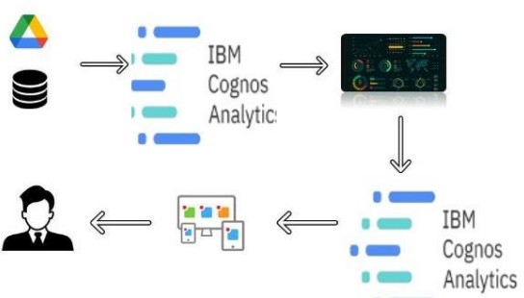

**Fig. 4**

* 1. Hardware/Software Designing

#### Hardware Requirements:

PC with sufficient processing power

#### Software Requirements:

IBM Cognos Analytics Web Browser Compatibility

Database Management System (e.g., IBM Cloud) Compatible Operating system

# Experimental Investigations

With a comprehensive solution development, a series of investigations were carried out to ensure the reliability and effectiveness of the sustainability analysis tool. The integration process underwent thorough scrutiny to maintain data integrity and consistency across diverse sources.

In parallel, the IBM Cognos data visualization tools were assessed for their effectiveness in translating complex sustainability data into clear and interpretable visualizations, focusing on user comprehension and engagement.

Temporal analysis validation was a critical step, involving the accurate tracking of historical data from 2000 to 2023. This process included cross-referencing with external sources to verify historical events and trends. The user-friendly dashboard underwent extensive usability testing to evaluate its effectiveness in providing a dynamic and customizable interface.

# Flowchart

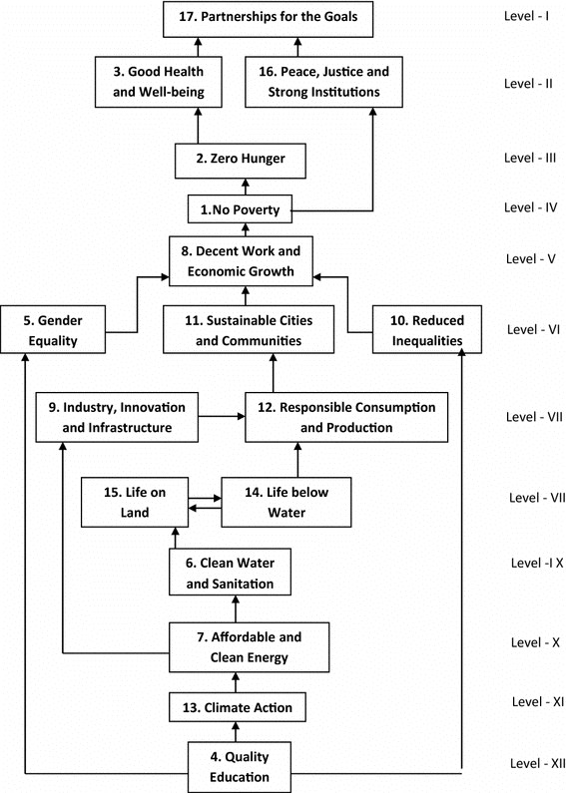

**Fig. 5**

# Results

## Finding 1:

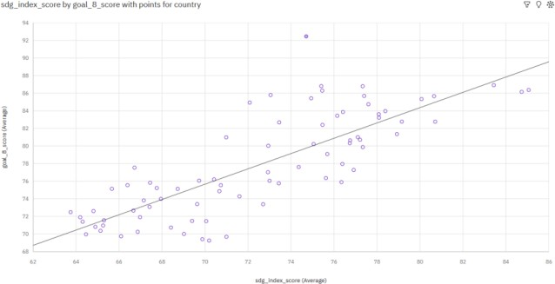

##### Fig. 6 Scatter plot: Sustainability vs. Economic Growth.

1. Cuba demonstrates exceptional economic growth, leading in Sustainable Development Goal 8 (goal_8_score), which encompasses decent work, economic growth, and industry innovation.
2. The divergence between economic growth (goal_8_score) and overall sustainability (sdg_index_score) is most pronounced in Cuba, with goal_8_score surpassing sdg_index_score by 17.74 points, highlighting a significant emphasis on economic aspects.
3. Notably, when the overall sustainability score (sdg_index_score) for Cuba is 74.71, there is a strikingly high score in economic growth (goal_8_score), indicating a distinct focus on economic development within the broader context of sustainable goals.
   1. Finding 2

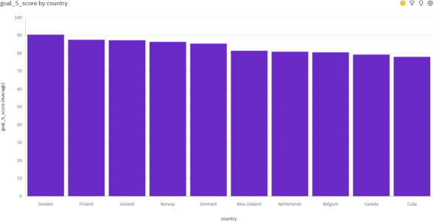

##### Fig.7 Gender Equality score by Country

* + - Sweden emerges as a leader in gender equality, holding the highest average score in Sustainable Development Goal 5 (goal_5_score).

### Finding 3

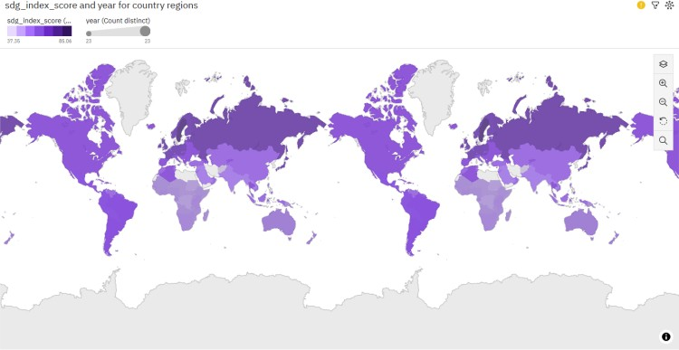

##### Fig.8 Overall Sustainability by Year for Country Regions

* + - Across all countries, the average overall sustainability score (sdg_index_score) stand at 63.69, providing a benchmark for evaluating global progress towards Sustainable Development Goals.
    - Notably, this score varies widely among nations, with South Sudan recording the lowest average sdg_index_score of 37.35, while Sweden leads with the highest average score of 85.06. These variations underscore the diverse sustainability challenges and achievements observed worldwide.

### Finding 4

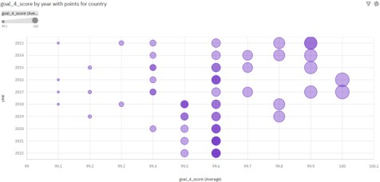

##### Fig.9 Education Score by Year with Country Points

* + - There is a robust upward trend observed in the scores related to Sustainable Development Goal 4 (goal_4_score), indicating positive advancements in education related outcomes globally.
    - Singapore stands out with the highest average score in Sustainable Development Goal 4 (goal_4_score), underscoring the nation's significant achievements and commitment to quality education.
    - According to the current forecasting trends, it is anticipated that the goal_4_score may reach

77.27 by the year 2024, suggesting a potential trajectory of further improvement in education-related indicators on a global scale.

* 1. Finding 5

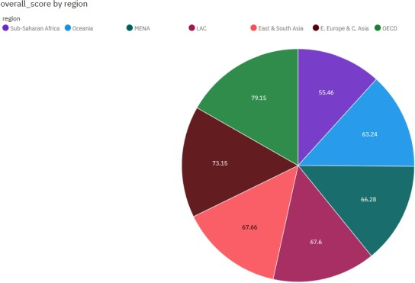

##### Fig.10 Overall score by region

* + - The most significant divergence between Sustainable Development Goal 12 (goal_12_score) and the overall sustainability score (overall_score) is observed in the Sub-Saharan Africa region, where goal_12_score surpasses overall_score by 37.95 points. This suggests a notable emphasis on responsible consumption and production practices in the region.
    - Sub-Saharan Africa and the OECD region exhibit the most unusual patterns in overall sustainability scores, indicating unique challenges and achievements in these areas.
    - Understanding and addressing these nuances is crucial for tailored sustainable development strategies.
    - Despite having the highest average score in Sustainable Development Goal 12 (goal_12_score), the Sub-Saharan Africa region is ranked #7 in the average overall sustainability score. This discrepancy underscores the complex interplay of diverse sustainability indicators and the need for comprehensive strategies to address multiple goals simultaneously.

### Finding 6

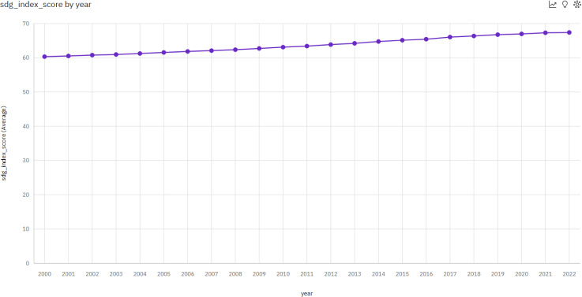

##### Fig. 11 Overall Sustainability by Year

* + - The Sustainable Development Goals' overall progress, as reflected in the sdg_index_score, appears unusually high in the years 2022 and 2021, suggesting notable advancements and achievements during this period.
    - Across all years, the average sdg_index_score stands at 63.69, providing a baseline for assessing global sustainability trends over time.
    - Notably, the average values of sdg_index_score vary from 60.31 in the year 2000 to 67.38 in 2022, showcasing fluctuations and potential advancements in global sustainability efforts over the years.

# Advantages & Disadvantages

The proposed solution integrates diverse data sources to provide a comprehensive view of global sustainability trends, using IBM Cognos Analytics for user-friendly visualizations and a dynamic dashboard. This facilitates real-time insights, temporal analysis, and regional comparisons, empowering stakeholders with valuable information. However, challenges include data accuracy dependencies, potential time lags in data availability, and complexities in predictive modeling.

The solution's reliance on IBM Cognos may introduce compatibility issues, and interpreting complex data relationships could be challenging for stakeholders. Addressing security concerns is crucial for safeguarding sensitive sustainability data.

##### Advantages:

* It can be connected to multiple data sources.
* Easily integrates with any other tool.
* Combination of data sources.
* Favorable technical service, always attentive.
* It is fully scalable.
* Everything works without a hitch, from its implementation to its general use.

##### Disadvantages:

* After configured, learning is a bit difficult, although later, one takes it until one understands it.

# Applications

The proposed solution has broad applications across various sectors. Policymakers can utilize its insights for data-driven policy formulation, allowing targeted interventions in areas that need attention. International development agencies can assess and compare country progress on Sustainable Development Goals (SDGs), guiding aid allocation.

Corporations aiming for sustainability can assess their impact and areas for improvement. Educational institutions can integrate the solution into curricula, fostering a deeper understanding of global sustainability challenges. Non-governmental organizations (NGOs) can leverage it for advocacy and awareness, conveying complex information through powerful visualizations. Investors and financial institutions can incorporate sustainability scores into decision-making processes, guiding responsible investments.

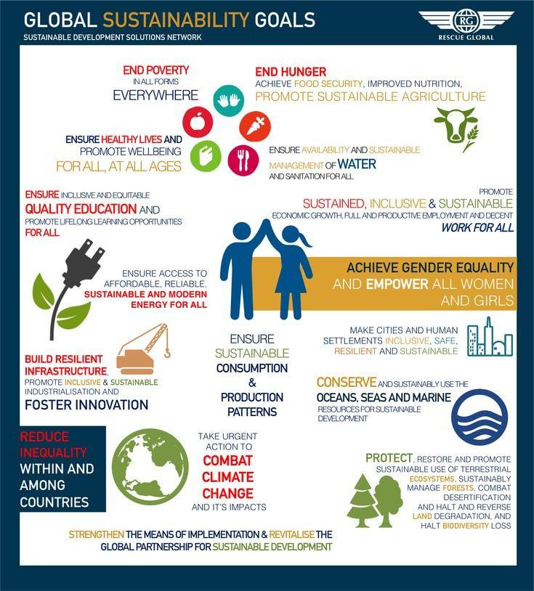

Researchers and academics can use the solution for in-depth studies on global sustainability trends, exploring correlations and patterns. Governments can engage with the public, providing transparent information on national SDG progress. The solution's adaptability allows it to cater to diverse applications, facilitating informed decision-making and contributing to global sustainable development efforts.

# Conclusion

In conclusion, "Visualizing Sustainability: A Cognos-based Analysis of Global Trends (2000-2023)" presents a robust solution for analyzing and visualizing progress on the Sustainable Development Goals (SDGs). Leveraging IBM Cognos Analytics, the project provides a user-friendly platform for stakeholders to gain comprehensive insights into global sustainability trends over the specified timeframe.

The dynamic dashboard and visualizations offer a nuanced understanding of complex data, allowing for in-depth exploration of trends, patterns, and correlations. The solution's applications span across policymaking, international development, corporate sustainability, education, advocacy,

investment, research, and public engagement, showcasing its versatility in addressing a wide array of needs.

Despite the advantages, challenges such as data accuracy dependencies, time lags, and complexities in predictive modeling need careful consideration. The solution's reliance on IBM Cognos may introduce potential compatibility issues, and interpreting complex data relationships could pose challenges for diverse stakeholders.

In essence, the project serves as a valuable tool for stakeholders seeking to make informed decisions in the pursuit of sustainable development. It provides a comprehensive overview of global sustainability trends, facilitating the identification of areas for improvement and targeted interventions. As the world strives towards achieving the SDGs, this solution stands as a powerful resource for enhancing understanding and fostering positive change.

# Future Scope

The future scope of "Visualizing Sustainability: A Cognos-based Analysis of Global Trends (2000-2023)" involves real-time data integration, machine learning for improved forecasting, and enhanced user interactivity. Expanding data sources to include climate, social, and economic indicators offer a more comprehensive view. Optimization for mobile devices ensures broader accessibility. Collaboration features, advanced security measures, and localized versions cater to diverse stakeholder needs. Integrating gamification elements and providing comprehensive user training enhance engagement and usability. These developments collectively aim to elevate the solution's impact on informed and sustainable decision-making.

# Bibliography

1. The Sustainable Development Goals website (UN): https://sdgs.un.org/goals
2. World Resources Institute (WRI): https://[www.wri.org/](http://www.wri.org/)
3. WWF - World Wildlife Fund: https://[www.worldwildlife.org/](http://www.worldwildlife.org/)
4. International Institute for Sustainable Development (IISD): https://[www.iisd.org/](http://www.iisd.org/)
5. The Guardian Environment section: https://[www.theguardian.com/uk/environment](http://www.theguardian.com/uk/environment)
6. Data Science Weekly: https://[www.datascienceweekly.org/](http://www.datascienceweekly.org/)
7. Information is Beautiful: https://informationisbeautiful.net/
8. IBM Cognos Analytics website: https://[www.ibm.com/products/cognos-analytics](http://www.ibm.com/products/cognos-analytics)
9. Cognos Analytics documentation: https://[www.ibm.com/support/knowledgecenter/SSEP7J_11.0.0/com.i](http://www.ibm.com/support/knowledgecenter/SSEP7J_11.0.0/com.i)
10. bm.swg.ba.cognos.cbi.doc/manuals.html
11. Cognos Community: https://community.ibm.com/community/user/businessanalytics/home
12. UN Global Pulse: https://[www.unglobalpulse.org/](http://www.unglobalpulse.org/)
13. IBM Sustainability Solutions with Cognos: https://www2.deloitte.com/content/dam/Deloitte/us/Documents/process-andoperations/us-cons-de loitte-and-ibm-global-ba-success-stories.pdf
14. Visualizing the SDGs with Cognos (case study): https://[www.ibm.com/docs/en/cognos-analytics/11.1.0?topic=guide-usercapabilities](http://www.ibm.com/docs/en/cognos-analytics/11.1.0?topic=guide-usercapabilities)
15. SDGs Dashboard using Cognos Analytics: https://[www.youtube.com/watch?v=_4wgXsqivSs](http://www.youtube.com/watch?v=_4wgXsqivSs)
16. UN Development Programme - Data Platform: https://unstats.un.org/sdgs/unsdg/
17. Explore Sustainability Trends & Tips (Google): https://explodingtopics.com/blog/sustainability-trends
18. Consumer sustainability trends & behaviour (Think with Google): https://[www.mckinsey.com/industries/consumer-packaged-goods/ourinsights/consumers-care-abo](http://www.mckinsey.com/industries/consumer-packaged-goods/ourinsights/consumers-care-abo) ut-sustainability-and-back-it-up-with-their-wallets